Evaluator: Pontus Svensson

Reviewer: Leonardo Iwaya

DATE: 27/03/2024

TASK: Assessment of appropriate recovery exercises.

Below, we can observe the process of evaluating one's exercise needs. Since the app's users are likely to be older, enhancing usability would involve implementing larger buttons, bigger text, and improved contrast between text and background. As demonstrated in the screenshots below, the low contrast between menu items and the background makes it difficult for users of all ages to read the text clearly. As of now, the app violates heuristic number one, **“visibility of system status”**.

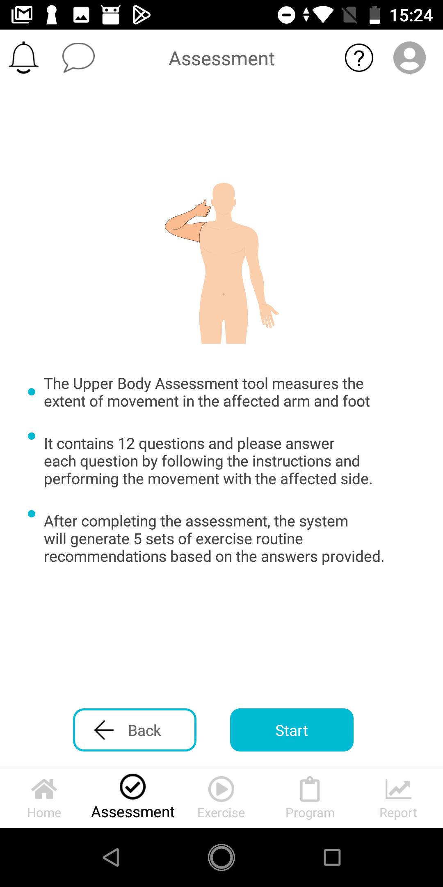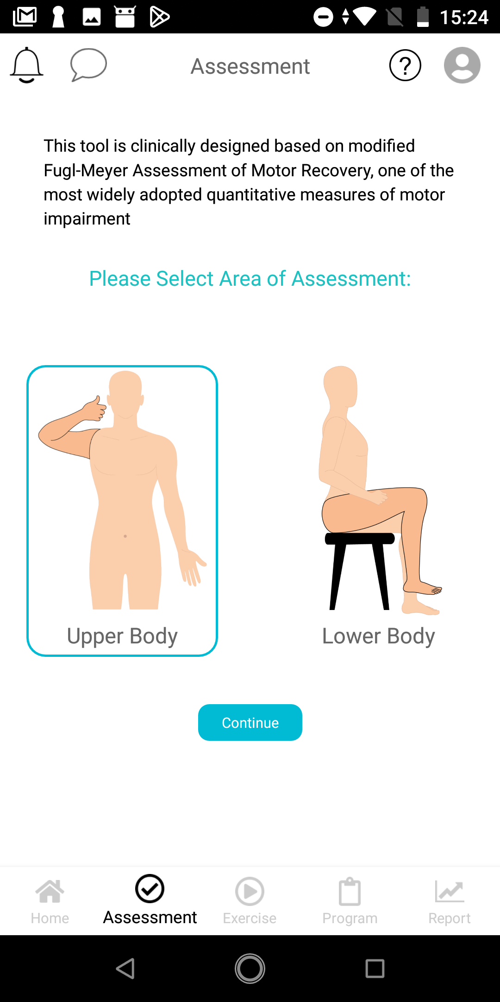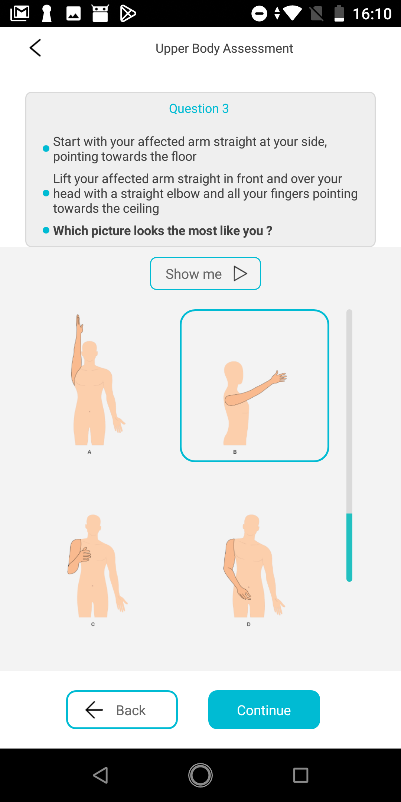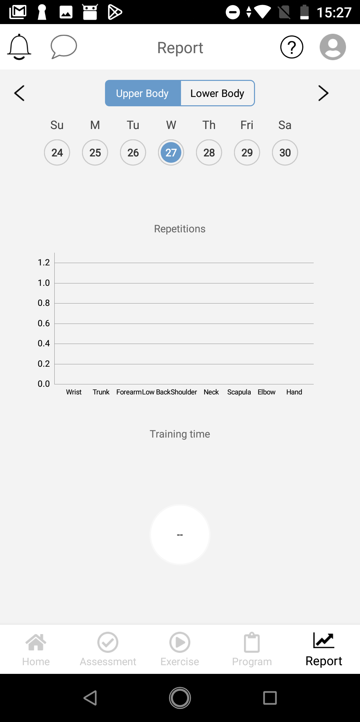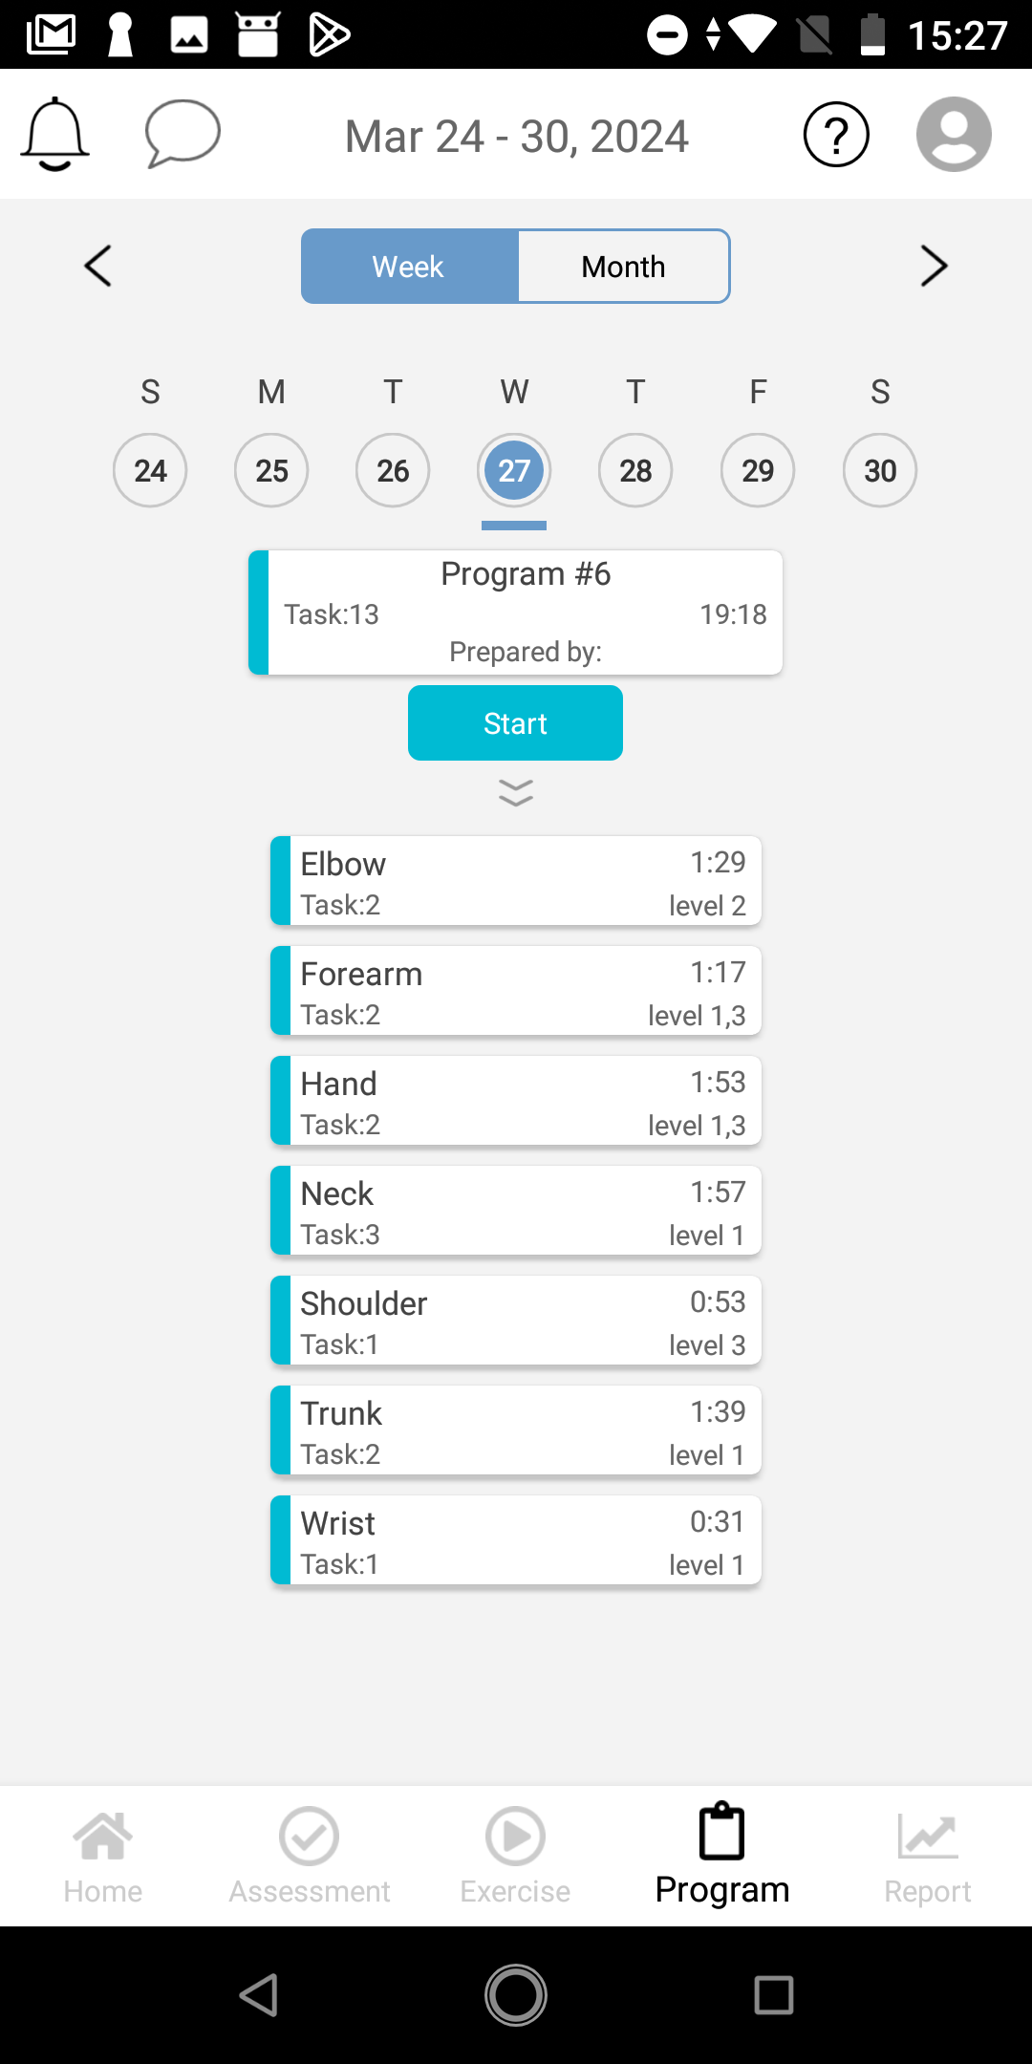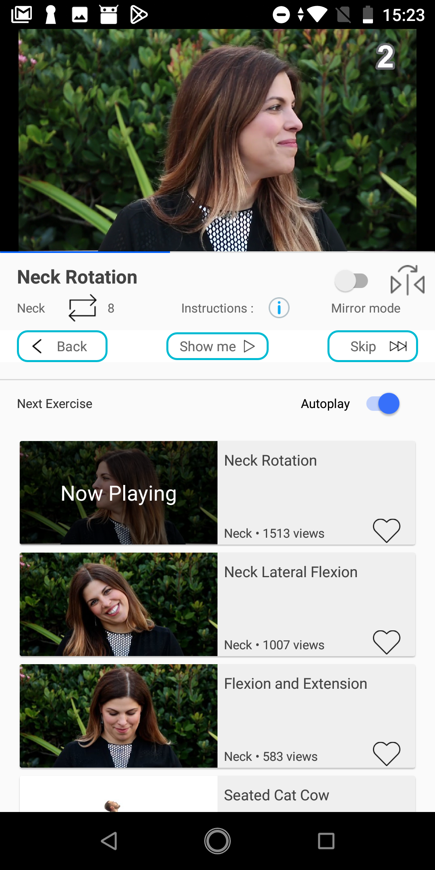

OTHER REMARKS:

In the screenshot below, we notice a message prompting the user to "Press again to exit MyTRCare." This message appears when the user presses the back button on their phone rather than a designated button within the app. Upon further observation, we see that the back arrow for navigating within the app is located at the top left corner. However, throughout the app, this back button/arrow is inconsistently placed, as evidenced by a different location—the lower left corner—in the second screenshot below. Such inconsistency violates the fourth heuristic, **"consistency and standards"**. Additionally, it undermines the third heuristic, **"user control and freedom"**, which emphasizes the importance of ensuring that canceling and navigating backward are straightforward and intuitive actions.

